**Insurance Fraud Detection Project: Model Evaluation Report**

**Introduction:** Insurance fraud is a pervasive issue impacting the financial stability of insurance companies. This project addresses the challenge by developing an advanced Insurance Fraud Detection system using machine learning and data analytics.

**Objective:** The primary goal is to create a proactive fraud detection system that can analyze large datasets, detect anomalies, and prevent fraudulent claims in real-time.

**Data Preprocessing:** The insurance claims dataset was loaded and processed:

* Removed unnecessary columns.
* Handled missing values in 'authorities_contacted'.
* Converted date columns to datetime.
* Encoded categorical variables using Label Encoding.
* Scaled numerical features using StandardScaler.

**Model Evaluation:** Multiple machine learning models were evaluated for fraud detection, including Logistic Regression, Decision Tree, Random Forest, Gradient Boosting, SVM, and k-NN.

**Results:** The table below summarizes the key performance metrics for each model:

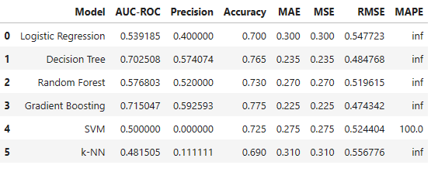

**Conclusion:**

* The models exhibited varying performance across metrics.
* Further refinement and hyperparameter tuning are recommended.
* The results lay a solid foundation for the iterative improvement of the fraud detection system.

**Project Justification:**

* The project addresses a critical need in the insurance industry by providing a proactive solution to combat fraud.
* Machine learning models, trained on preprocessed data, showcase the potential to enhance fraud detection capabilities.
* The code implementation and model evaluations serve as a crucial step toward building a robust fraud detection system.

**Next Steps:**

* Iterative model improvement through hyperparameter tuning.
* Experimentation with advanced algorithms and ensemble methods.
* Integration of the system into the insurance company's operational framework for real-time fraud prevention.